**BALLAD PROJECT PLAN v2**

**TEAM TRIAD**

**CALVIN DUPEE, HENRY MONTESANO III**

**11/12/21**

**Introduction**

**Scope and purpose of document**

(CD) This document contains the general outline, purpose, and feature set of the mobile application Ballad. The purpose of this is to keep us on track with our objectives for the application while also keeping it in accordance with our scope.

(HM) The Ballad mobile application is designed to serve as a new virtual environment for musicians around of the world to play and create music with one another. Musicians will be able to safely find and connect to other users through video or voice conferencing to play their favorite songs or collaborate on original songs. Ballad’s all-in-one toolkit provides everything a virtual musician needs to read music, keep tempo, record their sessions, and share their art with other artists. Through technology, Ballad allows users to create unique and memorable experiences and relationships with both accomplished musicians of the past and passionate artists of the future.

**System Scope**

*Problem/Opportunity Description (HM)*

In 2020, the COVID-19 pandemic upended the lives of millions of people around the world; one industry that was deeply affected was that of artists and musicians. No longer able to safely gather in person to collaborate on songs, musicians had to find workarounds to try to accomplish what was previously done in recording studios, schools, even backyards. These workarounds were sloppy at best, producing awkward jamming environments, poor recording outcomes, and overall apprehension and frustration for musicians. Ballad aims to provide a streamlined artistic environment that will relieve the stress of creating a virtual collaborative setting.

With all the disadvantages the pandemic has brought, it has also created opportunities for musicians to consider alternative ways of creating and sharing music without the need for physical interaction. As an all-in-one toolbox and social media platform, Ballad is the only application users will need to create music and share with other users. Focused on interactions between previously unacquainted users, Ballad presents both specialized and unrestricted ways for users to communicate and collaborate with artists without the barriers associated with differing locations and accessibility.

*Anticipated Business/Personal Benefits (RA)*

With this project, we hope to achieve a large user base that can come together to discuss, create music, and socialize with one another. We also hope to achieve a safe environment that users will have a good, and safe experience. We want to give aspiring musicians a platform to get their music out there, so others may see and enjoy.

One of the benefits is the ability to create music at any location with an internet connection. The free metronome and tuner are another benefit that allows musicians to properly get their timing down and tune their instruments. Also, the ability to save music is another benefit we expect to offer, with this benefit they can save their music and have the ability to distribute their own music. The ability to buy sheet music is another unique benefit to the app.

*System Capabilities (CD)*

One of the main features of the app are the fully customizable user profiles. Some options include users’ name, what instruments the user plays, users' location, what genres the user likes to play, and what the user feels their general skill level is.

The primary feature of the app are the live jam sessions. This allows multiple musicians to connect with each other through either just audio or audio/video sessions to play songs together. Users can connect to their friends or other users based on their preferred genres and instruments. Every session is recorded in real time should the user allow it; each person’s audio can be recorded as either a group recording or separated instruments and saved separately for clarity.

The recordings feature is an extension of the live jam sessions. The session recording files are saved directly to the app’s database for easy access. This allows any user to listen to previously recorded sessions through the in-app music player.

The final feature is an in-app sheet music store that allows users to purchase digital sheet music for them to view via the app. Users can search and filter their genre and artist preferences in order to easily find the exact sheet music they desire.

*System Context (CD & HM)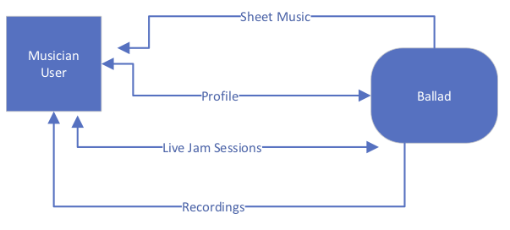*

**Schedule (CD & HM – See Microsoft Project attachment on Blackboard)**

**Staff Organization (CD & HM)**

Team Triad has gone through multiple staff changes throughout the semester. Originally, the team was formed by Rudis Argueta, Calvin Dupee, and Henry Montesano III taking the role of Team Leader. Now having gone through a restaffing and two team member losses, Calvin and Henry are directly collaborating with each other on most of the project responsibilities.

**Tracking and Control Mechanisms (CD & HM)**

The team has stayed in frequent communication with each other through Slack to schedule meetings and discuss project ideas. Using Blackboard’s File Exchange as well as Office 365, the group will be able to make frequent alterations and additions to the project plan throughout its lifecycle. Any finalized changes will be pushed to the Ballad Github repository. The team regularly meets every Tuesday afternoon to discuss the project deadlines for the week to stay on track and continue to further the project’s development.